**BIAS AND VARIANCE**

**DIAGNOSING BIAS AND VARIANCE**

**Understanding Bias and Variance**

* **High bias occurs when a model underfits the training data, resulting in high training error (J_train) and high cross-validation error (J_cv). This indicates that the model is too simple to capture the underlying patterns.**
* **High variance happens when a model overfits the training data, performing well on the training set (low J_train) but poorly on unseen data (high J_cv). This suggests the model is too complex.**

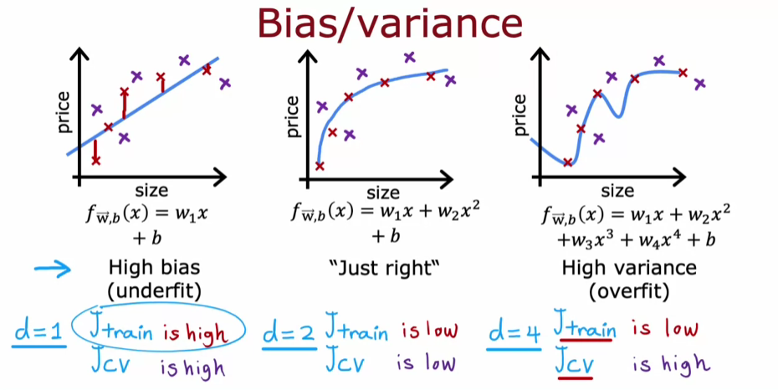

**Diagnosing Bias and Variance**

* **To diagnose bias, check if J_train is high; this indicates underfitting. For high variance, look for a significant difference where J_cv is much greater than J_train, indicating overfitting.**
* **A balanced model will have both J_train and J_cv low, suggesting it captures the underlying data patterns without overfitting or underfitting.**

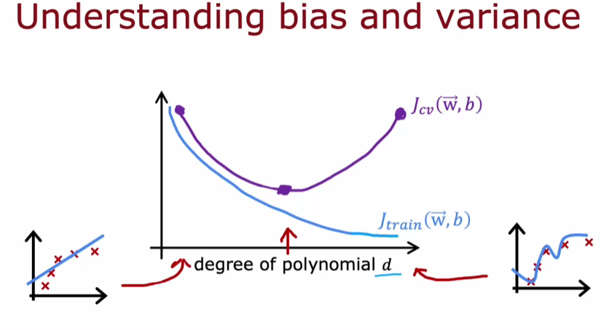

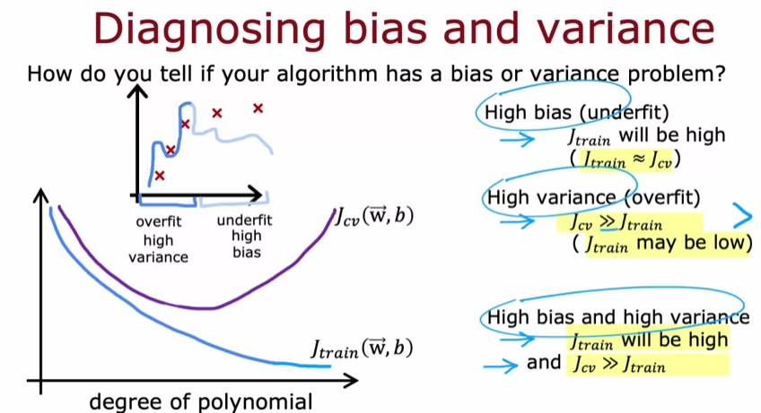

**REGULARIZATION AND BIAS/VARIANCE**

**Understanding Regularization and Lambda**

* **A large value of Lambda (e.g., 10,000) leads to high bias and underfitting, as the model keeps parameters small and approximates a constant value.**
* **A small value of Lambda (e.g., 0) results in high variance and overfitting, where the model fits the training data too closely but performs poorly on cross-validation data.**

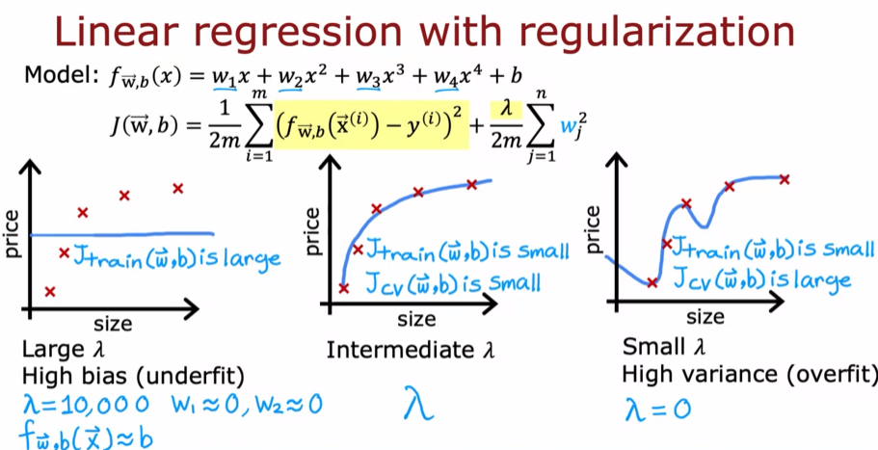

**Choosing the Right Lambda**

* **To find an optimal value for Lambda, you can use cross-validation by testing various Lambda values, minimizing the cost function, and evaluating the cross-validation error.**
* **The goal is to identify an intermediate Lambda that yields low training and cross-validation errors, indicating a well-fitted model.**

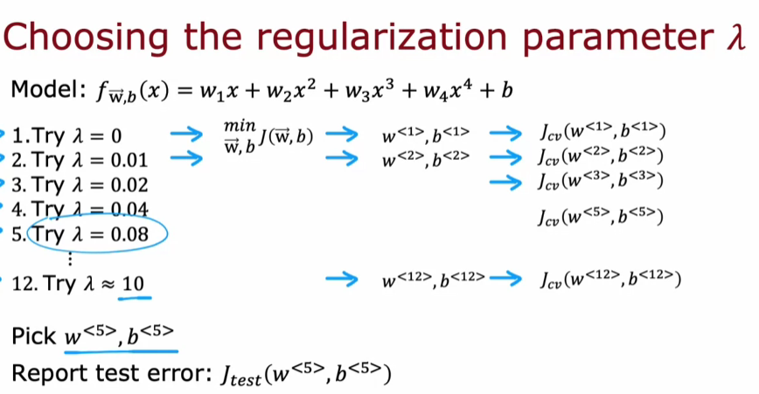

**Evaluating Performance**

* **The relationship between training error (J_train) and cross-validation error (J_cv) varies with Lambda; high J_train indicates high bias, while a large difference between J_cv and J_train suggests high variance.**
* **Cross-validation helps in selecting a Lambda that minimizes J_cv, leading to better model performance.**

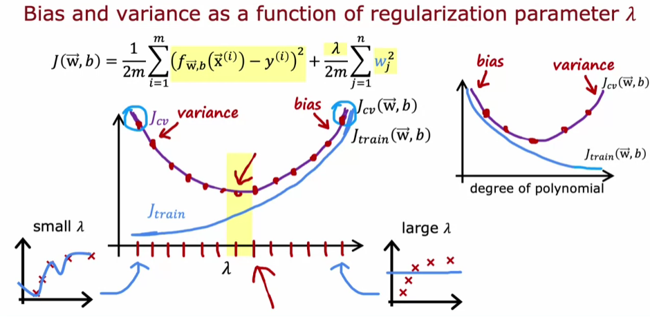

**ESTABLISHING A BASELINE LEVEL OF PERFORMANCE**

**Evaluating Training and Cross-Validation Errors**

* **Training error measures the percentage of incorrect transcriptions in the training set, while cross-validation error assesses performance on a separate dataset.**
* **A significant gap between training error and cross-validation error indicates high variance, while a high training error relative to human performance suggests high bias.**

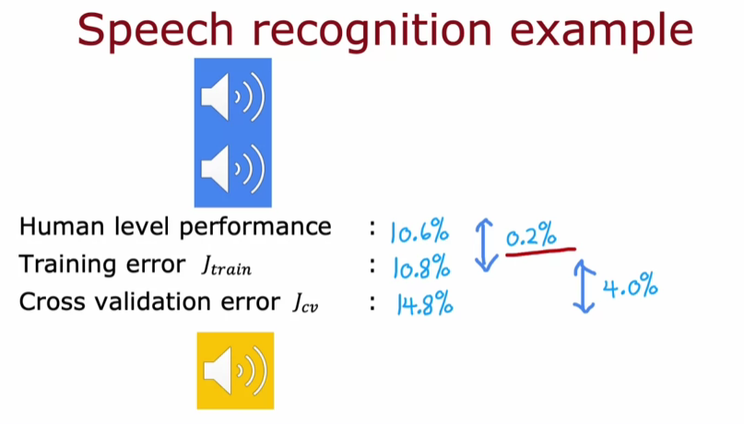

**Human Level Performance as a Benchmark**

* **Establishing a baseline level of performance, such as human transcription accuracy, helps in evaluating the effectiveness of the learning algorithm.**
* **If the training error is close to human performance, the algorithm may be performing well, even if the training error seems high in isolation.**

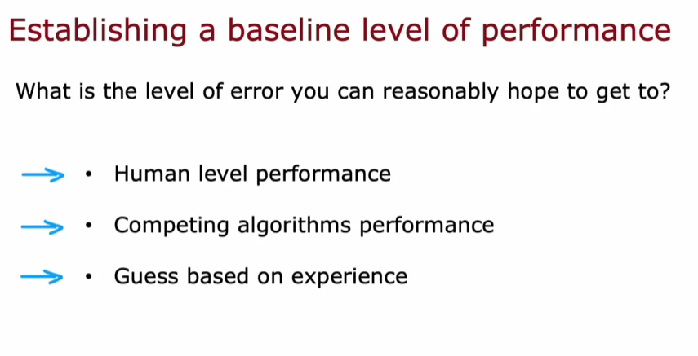

**Understanding Bias and Variance**

* **High bias is indicated by a large difference between training error and the baseline, while high variance is indicated by a large difference between training and cross-validation errors.**
* **It is possible for an algorithm to exhibit both high bias and high variance, which can complicate performance evaluation.**

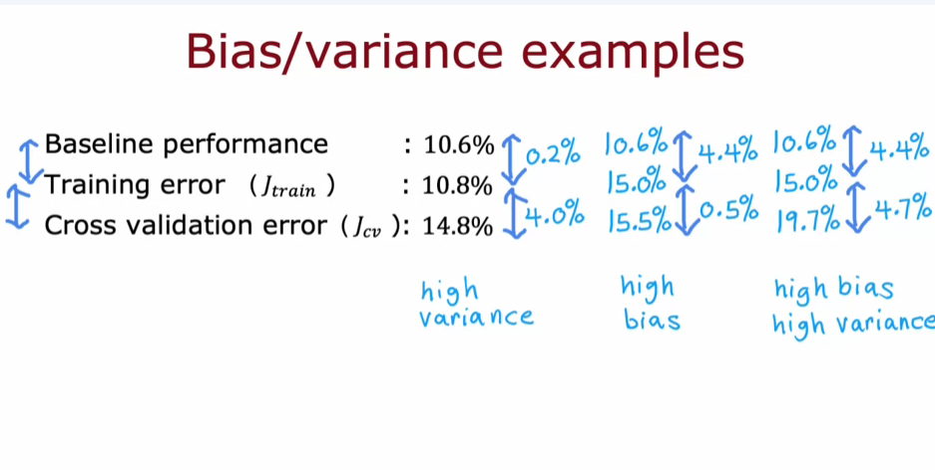

**LEARNING CURVES**

**Understanding Learning Curves**

* **Learning curves plot the training error (J_train) and cross-validation error (J_cv) against the training set size (m_train). As the training set size increases, J_cv typically decreases, indicating better model performance.**
* **Interestingly, J_train may increase with larger training sets due to the complexity of fitting all examples perfectly, especially with models like quadratic functions.**

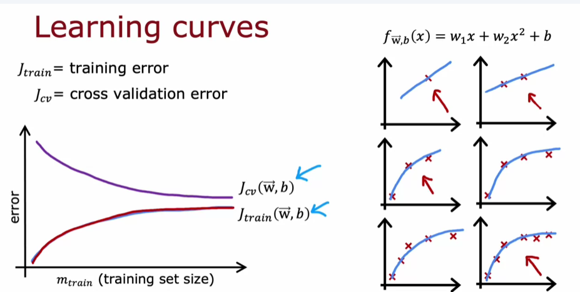

**High Bias vs. High Variance**

* **High bias (underfitting) occurs when a model is too simple, such as a linear function. Both J_train and J_cv may plateau, indicating that more data won't significantly improve performance.**
* **High variance (overfitting) happens when a model is too complex. J_train can be very low, but J_cv remains high. Increasing the training set size can help reduce J_cv and improve model performance.**

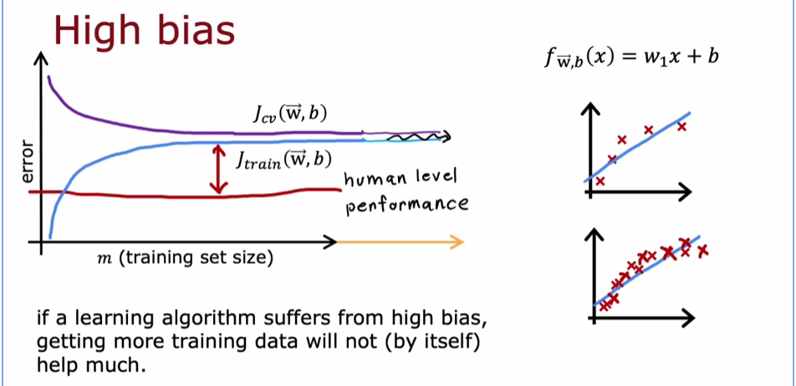

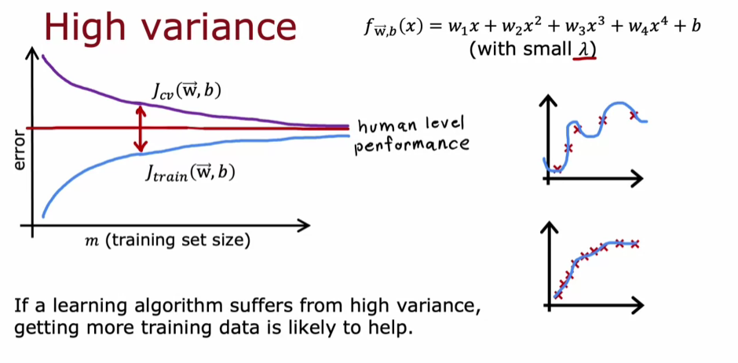

**Practical Application**

* **Plotting learning curves can help visualize whether a model suffers from high bias or high variance. While this can be computationally expensive, it provides valuable insights into the m**

**DECIDING WHAT TO TRY NEXT REVISITED**

**Understanding Bias and Variance**

* **High bias indicates that a model is too simplistic and fails to capture the underlying patterns in the data, leading to poor performance even on the training set.**
* **High variance suggests that a model is too complex and overfits the training data, performing well on it but poorly on unseen data.**

**Strategies to Address Bias and Variance**

* **To reduce high variance, you can get more training examples or simplify the model by reducing the number of features or increasing the regularization parameter (Lambda).**
* **To address high bias, you can add more features, include polynomial features, or decrease the regularization parameter to allow the model more flexibility.**

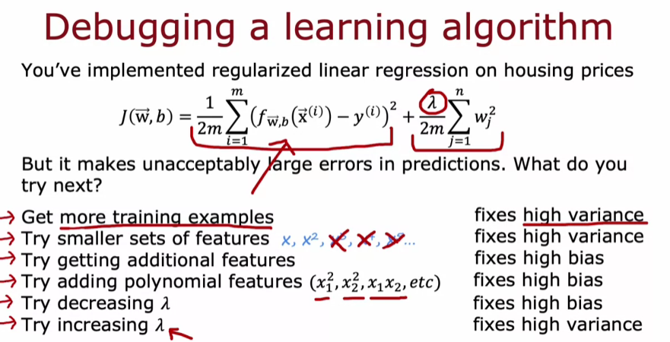

**BIAS/VARIANCE AND NEURAL NETWORKS**

**Understanding Bias and Variance**

* **High bias occurs when a model is too simple, leading to underfitting, while high variance arises from overly complex models that fit noise in the training data, resulting in overfitting.**
* **The goal is to find a balance between bias and variance to minimize cross-validation error.**

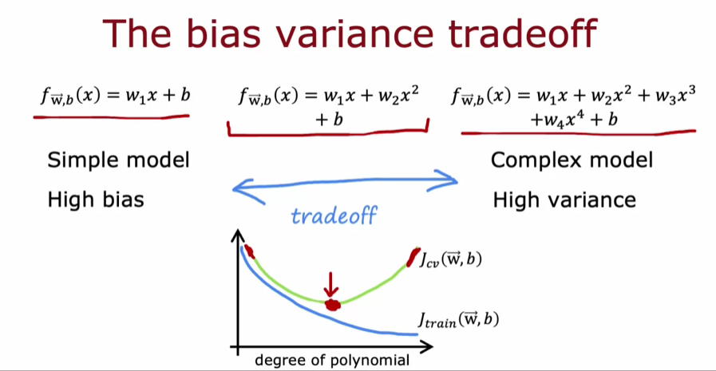

**Neural Networks and Their Advantages**

* **Large neural networks can effectively reduce bias, as they can fit complex functions well, especially when trained on moderate-sized datasets.**
* **To address high variance, acquiring more data is often a recommended strategy, allowing the model to generalize better.**

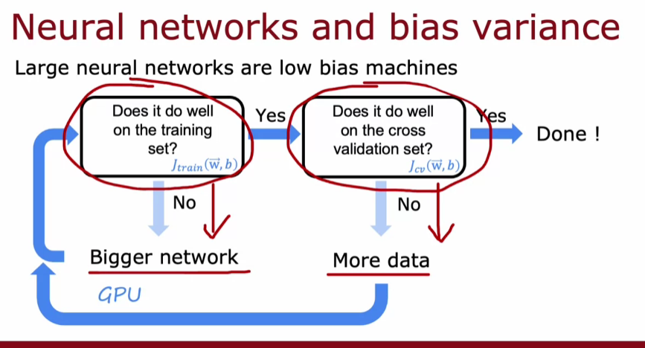

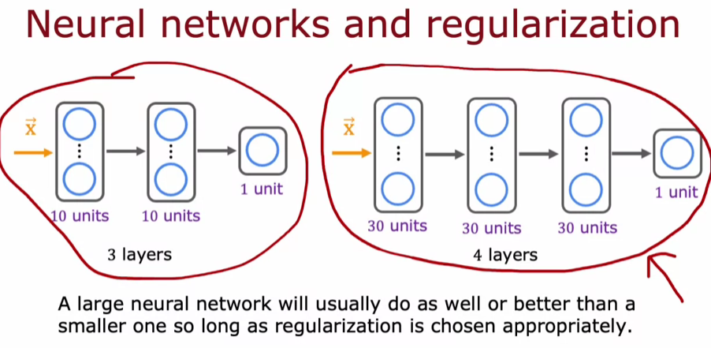

**Practical Steps for Model Improvement**

* **Start by training the model and evaluating its performance on the training set. If performance is low, consider increasing the network size.**
* **After achieving good training performance, check the cross-validation set to identify any variance issues, and if necessary, gather more data or adjust the model accordingly.**